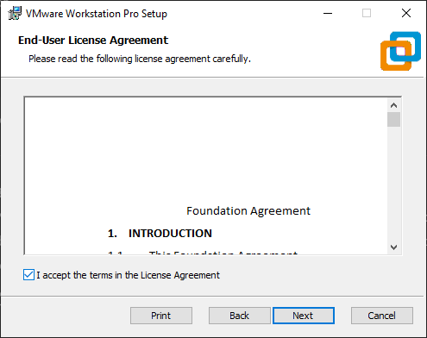

***Cloud Computing – Lab 1***

***Name : Sarosh Majeed***

***Reg no : 2023-BSE-059***

